Healthy Start Animation videos

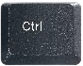
To download the animation videos:
- On your keyboard hold the Ctrl key ( ) and click “Request access” in the table below.
- An blank email addressed to our Public Health inbox will appear. Please state your name, organisation and that you would like to access to the animation videos and click send.
- Our team will then grant you access by sending a SharePoint link where you can download the animations.

Animation | Click image to View Animation | Clrt + Click to request access to download
Animation 1: Save Over £1200 on Food and Milk | 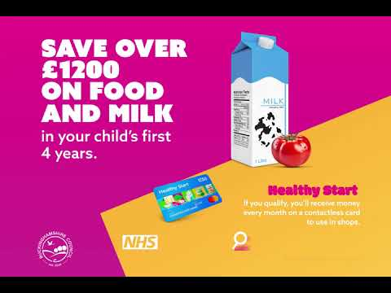 | Request access
Animation 2: Save Over £1192 on Food and Milk -Green 1 | 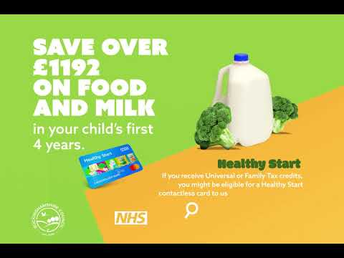 | Request access
Animation 3: Top Up Your Shop - Orange | 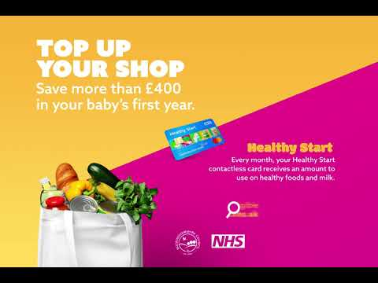 | Request access
Animation 4: Save £34 Per Month - Blue | 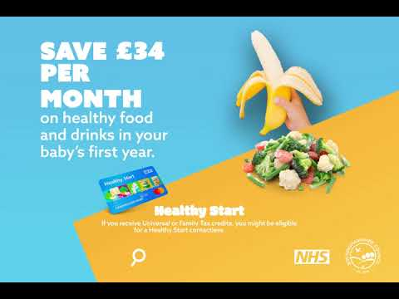 | Request access
Animation 5: Savvy Parents Save Pounds - Orange | 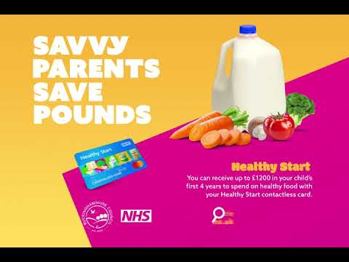 | Request access
Animation 6: Save Over £1200 on Food and Milk -Green 2 | 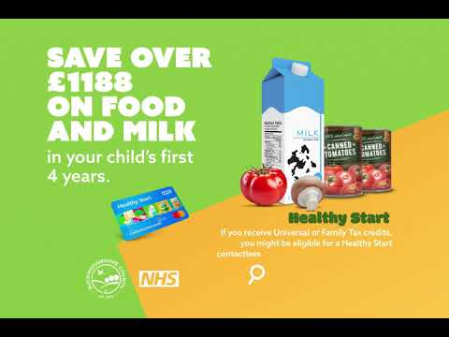 | Request access

